**Thank You Volunteers!**

**Readers:**

8:00: Michael Adams 10:15: Warren VanGenderen

**Gift Counters: Welcome Table:**

Pam Flores

**Accounts Payable Social Media**

**Volunteer: Volunteer:**

Louisa Sandvig Andi Dornan

**Pinnacle Newsletter Fellowship Snacks:**

**Volunteer:**

Barb Huhn

**HOSPITALITY**

Sunday Fellowship Snacks for the Lobby are welcome and appreciated. Please contact Pam, pflores@pcjh.org.



**Worship Service 10:15am April 29th, 2018**

**Thoughts for Reflection**

*"Grace does not depend on what we have done for God but rather what God has done for us. Ask people what they must do to get to heaven and most reply, "Be good." Jesus' stories contradict that answer. All we must do is cry, "Help!"" ~ Philip Yancey*

*"Grace is something you can never get but can only be given. There's no way to earn it or deserve it or bring it about anymore than you can deserve the taste of raspberries and cream or earn good looks."*

*~ Frederick Buechner*

*“All human nature vigorously resists grace because grace changes us and the change is painful.” ~ Flannery O' Connor*

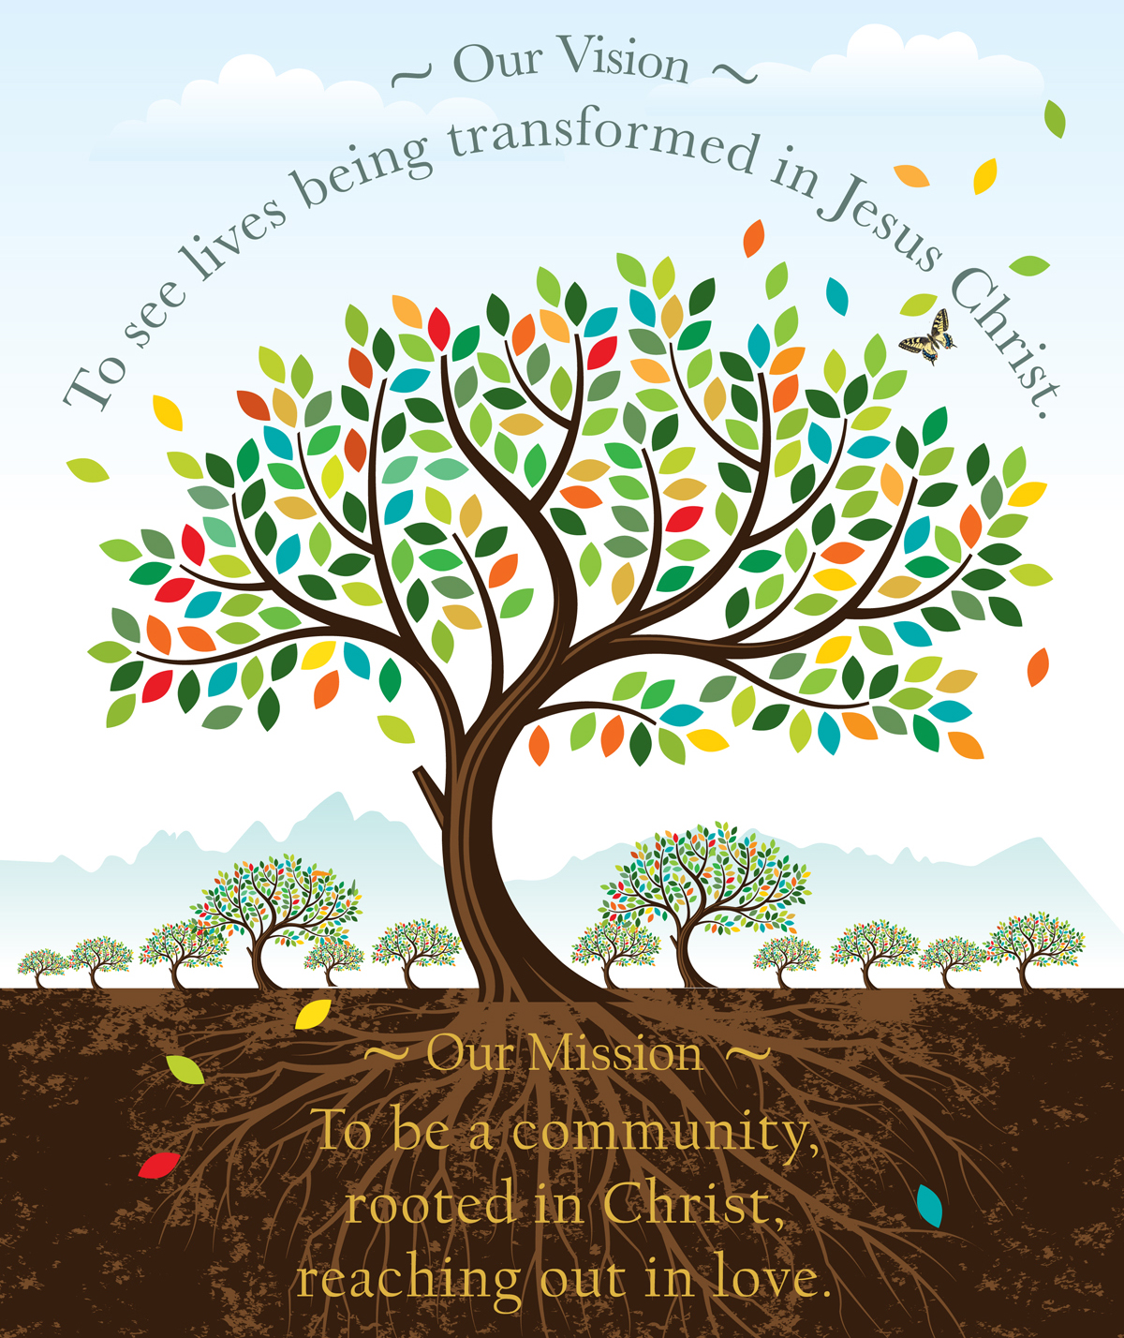

* Review last week
* Worship & Program Attendance Sheet

j

PCJH Holy Land Pilgrims standing and kneeling proud with Twintours guru Andre Boubarak at Tel Megiddo Park in Israel.

Sermon Notes:

**Women’s Bible Study**

Tuesdays at 12:00pm with Pastor Ben in the Matthew Room

**Men’s Bible Study**

Thursdays at 12:00pm with Pastor Ben at Jackson Whole Grocer, upstairs in the Community Room

**Ascent (20’s & 30’s)**

Weds at 7pm, contact Karin at 224.623.0112 to join this week

***Who Is This Man? The Unpredictable Impact of the Inescapable Jesus***

Sundays at 9am in the Genesis Room with Kathy Robertson

***Surprised by Hope: Rethinking Heaven, the Resurrection, and the Mission of the Church***

Wednesdays at 5:15pm in the Genesis Room with Pastor Tammy

**Holy Land Trip**

*April 22nd – May 3rd*

Thank you for continuing to keep our PCJH Holy Land Pilgrims in your prayers for safety, health, fun and transformation! Follow alongside their journey, daily updates are being shared to Instagram *(pc_jh)* & Facebook *(Presbyterian Church of JH)*.

**Brunch with Dr. Mary Neal**

*Sunday May 6th at 11:30am*

Next Sunday! Dr. Mary Neal will be sharing her story with the community, all are invited to come engage in her story of hope. Invite your friends to this special event PCJH is hosting in Hayden Hall.

**Parents’ Night Out**

*Friday May 4th from 5:30-8pm*

PCJH Children’s Ministry is hosting PNO for children cradle-5th grade age. Parents, enjoy an evening to yourselves! If you’re interested in playing with some neighborhood kids for couple hours please contact Dylan Wade (dwade@pcjh.org).

**Upward Information Meeting**

*May 9th at 7pm*

Join us immediately following community dinner, in the Genesis Room. Jim Hamilton, our fearless leader and Upward Director, and the Regional Director for Fellowship of Christian Athletes, will be hosting an informational meeting for anyone that might have an interest in serving or participating in this ministry.

**Annual PCJH Rummage Sale**

*Sat., June 9th from 8:30am-noon*

The Rummage Sale team is now taking your spring cleaning donations! We are currently collecting reasonably sized items in the Luke Room. The trailer will available to collect larger items starting on May 7th. Please contact Irene Lund or Diane Nichols ## with questions or to learn how to volunteer for this anticipated community event!

**UPCOMING EVENTS & ACTIVITIES**

**

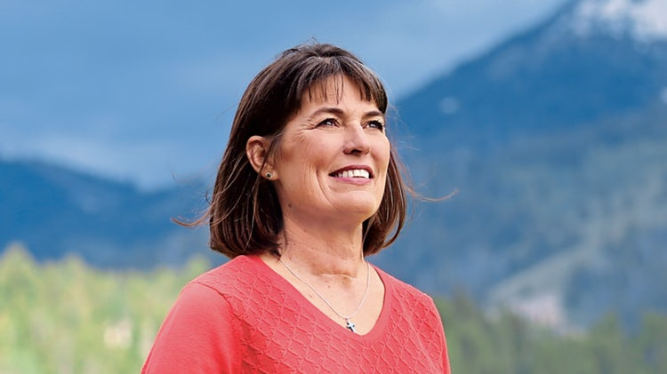

**

**

**

**Community Dinners**

PCJH gathers intentionally as a community for a delicious meal on Wednesdays from 6:15 - 7pm in Hayden Hall. All from the Jackson community are welcome, especially those in need of a meal. Donations for this mission are appreciated but not necessary.

**Worship Services**

*Sunday 8am in the Chapel, traditional Worship Service*

*Sunday 10:15am in the Sanctuary, Worship with Praise Band*

**ADULT CLASSES**









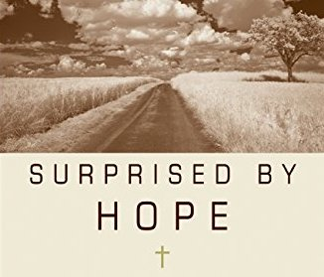

**GIVING**

*"Each of you should give what you have decided*

*in your heart to give, not reluctantly or under compulsion,*

*for God loves a cheerful giver." - 2 Corinthians 9:7*

There are many ways to give

in addition to the baskets passed in worship…

 **Mail** - a check to the Church office *(no cash)*

 **Online** - by clicking on the yellow Donate button

on the bottom right of the screen, pcjh.org

 **Text** - by texting a dollar amount to 307-200- 2175. (You will need to provide billing information the first time).

 **Credit** or debit card payments, please contact

Kim Bogen at kbogen@pcjh.org.

**Today! Pizza Picnic**

*11:30am – 1:30pm*

PCJH Middle School youth are spending the afternoon with St. John’s Episcopal youth. All are invited for lunch, lawn games and discussion. Meet in Hayden Hall at PCJH at 11:30am.

**Senior Sunday**

We are preparing to celebrate our graduating high school seniors on June 3rd. Please email Liz Collins for more information at lcollins@pcjh.org.

**Little Lambs Preschool**

***Registration for the 2018-2019 school year is open***

Little Lambs provides a loving environment that promotes the social, physical, intellectual and spiritual development for your child. For more information please contact Amanda Lack, alack@pcjh.org or visit pcjh.org/littlelambs.

**JOY Summer Camp**

***Registration is open &***

***Hiring for Summer Positions***

Register for JOY Summer Camps today, opportunities for preschool through middle school students. A variety of counselor positions and program staff are open for summer employment! Contact Children's Ministry Coordinator Dylan Wade at dwade@pcjh.org to learn more.

**Music Ministry**

PCJH offers Adult & Children’s choirs and a Music Academy. Email Kenny Hadden at music@pcjh.org to get involved.

**CHILDREN & YOUTH MINISTRY**

**Nursery**

0-3 years old

Sundays, 8:00-11:30am

**Sunday School**

We gather weekly during the 10:15 worship service, after *A Time with Children*. Classes are based on age groups: 4yrs-K, 1st-2nd grade, & 3rd-5th grade. We strive to develop a loving personal relationship with each child and help them grow in their relationship with Jesus Christ.





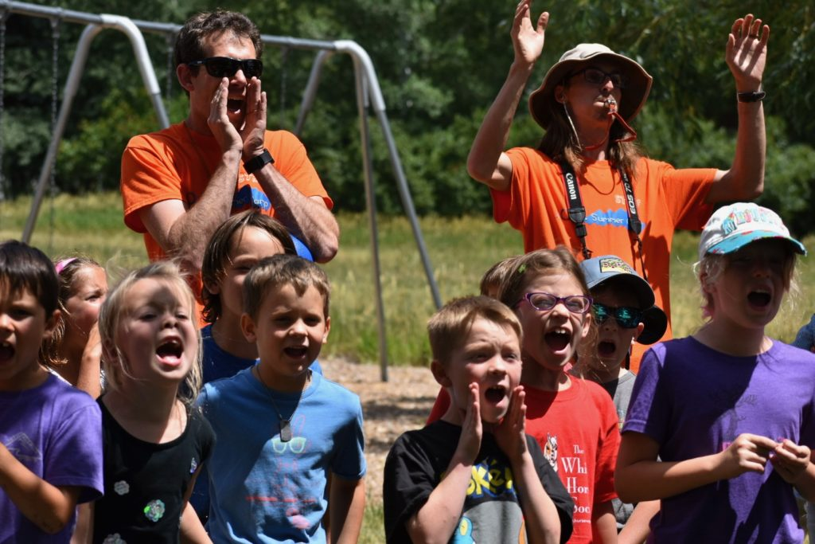

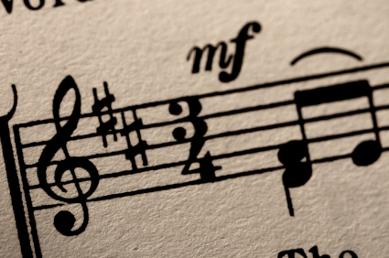

**GET TO KNOW US**

**Pastoral Staff**

Rev. Ben Pascal bpascal@pcjh.org

*Senior Pastor x 101*

Rev. Tammy Mitchell tmitchell@pcjh.org

*Associate Pastor x 104*

**Office Staff**

Cindy Dahlin cdahlin@pcjh.org

*Church Administrator x109*

Liz Collins lcollins@pcjh.org

*Communications Coordinator*

Pam Flores pflores@pcjh.org

*Office Assistant x107*

**Program Staff**

Kenny Hadden music@pcjh.org

*Worship Coordinator x123*

Amanda Lack alack@pcjh.org

*Little Lambs Director x111*

Dylan Wade dwade@pcjh.org

*Children’s Ministry Coordinator x103*

Liz Collins lcollins@pcjh.org

*Youth & Young Adult Ministry Coordinator*

Madelaine German

*Pianist*

**Ruling Elders**

Ruling Elders are the spiritual leaders of the church.

Session meetings are the third Tuesday of every month at 5:30pm.

|  |  |  |
| --- | --- | --- |
| Class of 2018 | 2019 | 2020 |
| Barb Andrews  *Youth Ministry* | Alan Lund*  *Finance* | Kathy Robertson  *Vision* |
| Pat Wright  *Stewardship* | Meg Womack  *Congregational Life* | Caryn Haman  *Personnel* |
| Peter Keenan  *Buildings & Grounds* | Aaron Nydam  *Children’s Ministry* | Ken Blount*  *Clerk of Session*  *Adult Ministries* |
| Warren VanGenderen  *Mission* |  | Tom Segerstrom  *Nominating &*  *Assimilation* |

**Deacons**

Deacons provide the ministry of compassion

and service for those in need.

|  |  |  |
| --- | --- | --- |
| Class of 2018 | 2019 | 2020 |
| Jen Baki | Liz Jorgenson | Nancy Brumsted* |
| Barb Huhn* | Annie Mueller | Jackie Montgomery* |
| Paula Jorgenson | Marge McCallister | Carol Poole* |
| Tena Webb* | Alicia Neathery | Sandra Zender* |
| Erin Rosenberg | Kenlyn Long* | Michael Schrotz |
| Deb Keenan | Dorothy Neckels | Claudia Schrotz |
| Yvonne Henze* | Susan Conner | George Scarlett |
|  |  | Bill Klyn |

*Serving second term

**HEARING GOD’S WORD**

**Old Testament Reading** Psalm 103:1-18

**New Testament Reading** 1 John 3:1-2

**Hymn of Praise**

*Great Is Thy Faithfulness (Hymn 276)*

**Gospel Lesson** Luke 15:11-32

**Time for Reflection and Study** Rev. Tammy Mitchell

***Welcome Home***

**BEING SENT INTO THE WORLD**

**The Benediction Sung**

*Let There Be Love Shared Among Us*

**The Benediction Spoken**

**Fellowship in the Lobby**

*(Please enjoy food and fellowship after the service,*

*and stop by the welcome table on your way out)*

_______________________________________________

**Welcome Visitors!**

If you are new to PCJH we want to welcome you – we are glad you are here!  We hope you feel at home here and experience God’s presence and grace today. We would love to get to know you, so please leave your information on a **welcome pad**, located in each row. **Nametags** are available at the welcome table to help us all greet one another.

**Prayer Requests**

If you have a prayer you’d like to send to our prayer

team, you may do so by filling out a request at

pcjh.org or by emailing your request to the Church

Office at office@pcjh.org.

If you’d like to be a part of this prayer team, please email Cindy Dahlin at cdahlin@pcjh.org, and your email

address will be added to our prayer team.

_______________________________________________



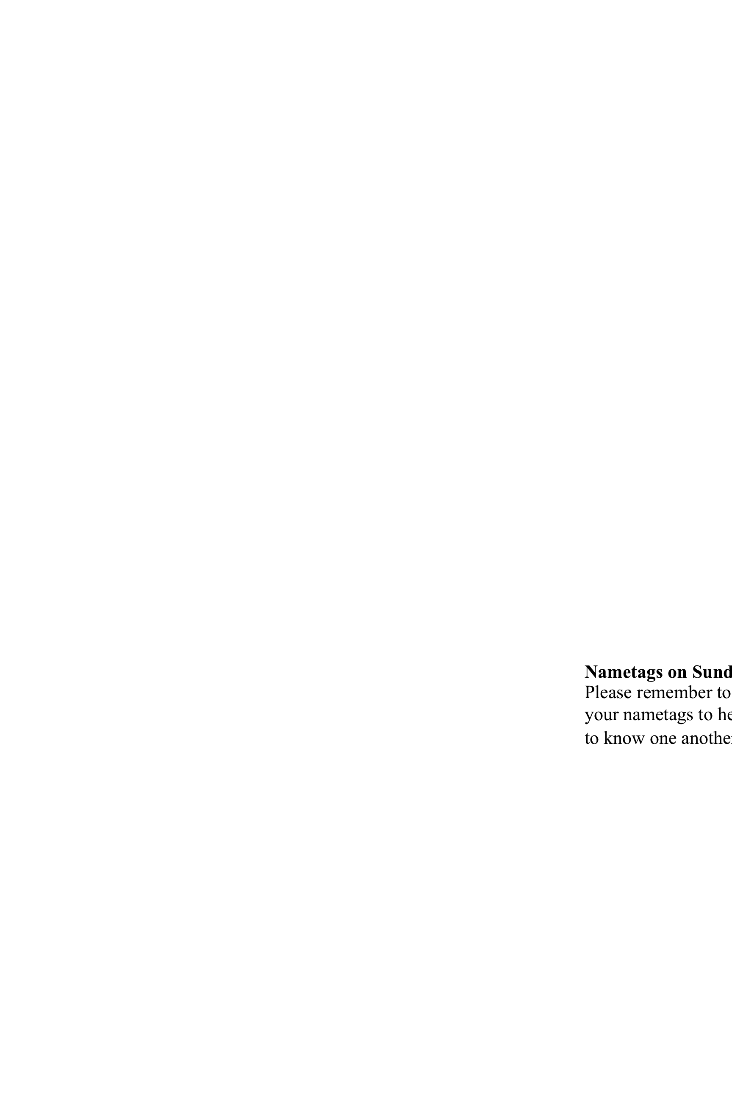

**Stay Connected:**

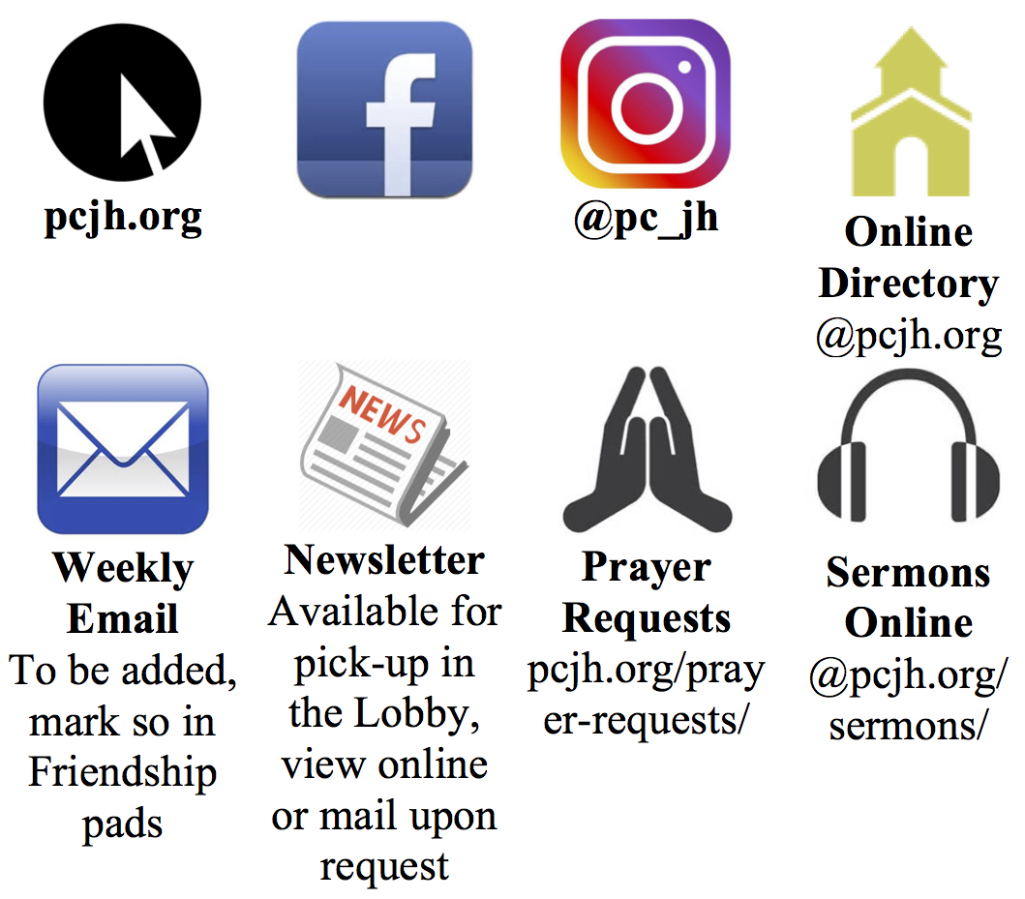

**COMING TOGETHER TO WORSHIP**

**Song of Gathering**

*Love Divine, All Loves Excelling (Hymn 376, v. 1, 2, 4)*

**Welcome and Opening Prayer**

**Songs of Praise**

*Blessed Be Your Name*

*Shine On Us*

**Prayer of Confession**

God of grace and love, forgive us when we wander away from your promises; when we seek to fulfill our desires above all else. Forgive us when we withhold from others the forgiveness we seek for ourselves. Forgive us when we have failed to understand another’s difficulty and struggle, and have withheld a measure of grace. Many times we have failed to allow another person to work through his or her journey and have only criticized or judged them. Forgive us, God, when we have made it about us, and have become complacent in seeking your presence, your will, and your way for our lives. Welcome us into your loving embrace. Warm us once more with your grace that we may know your mercy and reach out with loving arms to a world in need of your compassion, a world in need of your love In Christ's name we pray. Amen

**Words of Assurance**

**Song of Response**

*Amazing Grace (Hymn 280, v. 1)*

**Passing the Peace of Christ**

*(Take a few moments to greet one another)*

**SHARING LIFE TOGETHER**

**Time with Children**

*(Children are now dismissed to Sunday School)*

**News of the Church Family**

*(Please sign and pass the welcome pads)*

**Pastoral Prayer and the Lord’s Prayer**

*(forgive us our sins…)*

**Giving Generously of our Tithes and Offerings**

*(Electronic giving instructions are on the*

*inside of this bulletin)*

**The Doxology**

*Hymn 592*