**Thank You Volunteers!**

**Readers: Hospitality Team:**

8:00: Warren Myers

10:15: Jane Lavino Lynn & Carol Kelleghan, Randy Reedy, Pat Wright, & Dorothy Neckels

**Gift Counters Welcome Table:**

Alicia Neathery Ingrid Watsabaugh

Kathy Johnson

**Pinnacle Newsletter Fellowship Snacks:**

**Volunteer:** Sandra Guido, Susan Ordway,

Barn Huhn Jane Lavino, Robyn Jones, Meg Womack & Sue Consolo Murphy

**Accounts Payable** **Volunteer:** Louisa Sandvig

**HOSPITALITY**

Sunday Fellowship Snacks for the Lobby are welcome & appreciated. Please contact Pam, pflores@pcjh.org.



**Worship Service 10:15am June 4, 2017**

**Thoughts for the Day**

*“If you would change the culture, you must first be changed by Christ.” -Jim Denison*

*“God chose to introduce himself to us in the first verse of Genesis as a Creator. And yet so few Christians really understand the power of creativity to influence the culture.” -Phil Cooke*

*“Christians should live in the world, but not be filled with it. A ship lives in the water; but if the water gets into the ship, she goes to the bottom. So Christians may live in the world; but if the world gets into them, they sink.”*

*-Dwight L. Moody*

*“We face a changing culture by faith in a changeless Christ.” -H.B. Charles Jr.*

____________________________

The Presbyterian Church of Jackson Hole

is a church where every member is a minister,

called to pass on the faith, as we…

**Gather** to love God and others;

**Grow** to know and follow Jesus; and

**Go** to make a difference

in the world.

1251 South Park Loop Road

P.O. Box 7530

Jackson, WY 83002

307.734.0388

[www.pcjh.org](http://www.pcjh.org)

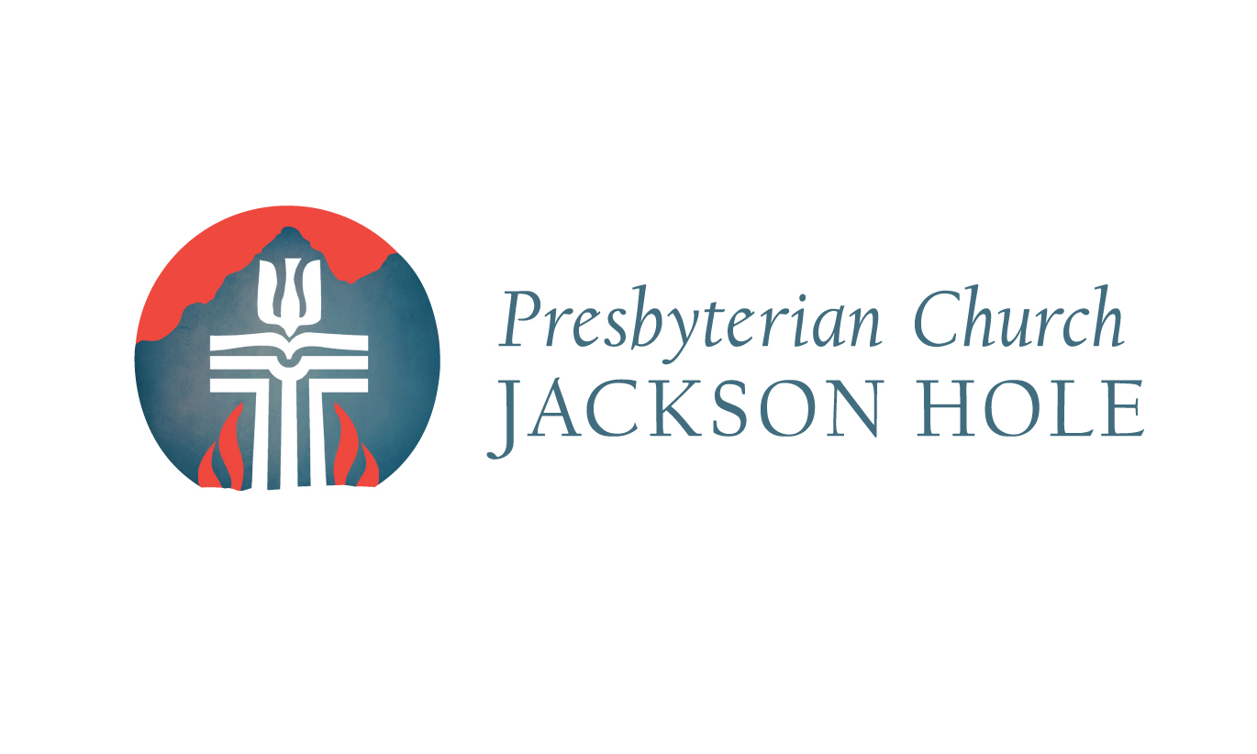

* Review last week
* Worship & Program Attendance Sheet
* Fine Furniture Sale on Saturday 9:00am to 12:00pm
* Wedding in Chapel on Saturday at 4:00pm
* Church Information Class on Sunday, Oct 16th, 11: 2:00pm (childcare?)
* Staff Lunch on Wednesday, Oct 19th at 12pm
* Budget Season (start planning)
* Staff/Session Christmas Party
* Staff Retreat Follow-Up (rule of life, goals, covenant,
* Quarterly Mini-Retreats

**Holy Land Pilgrimage**

April 22-May 3, 2018  
Join others from PCJH and the Jackson Hole community on a pilgrimage to the land of the Bible to walk in the footsteps of Jesus. Please contact Pastor Ben if you are interested in more information, bpascal@pcjh.org.

**Music Department**

Adult & Children’s choirs, and music lessons (piano, guitar, strings & voice). Contact

Kenny Hadden [music@pcjh.org](mailto:music@pcjh.org).

Listen to our worship music on

the ‘pcjhmusic’ playlist on Spotify.

**GIVING**

*"Each of you should give what you have decided*

*in your heart to give, not reluctantly or under compulsion,*

*for God loves a cheerful giver." - 2 Corinthians 9:7*

Giving generously is essential to our spiritual life and reflects our gratitude to God. There are many ways to give

in addition to the baskets passed in worship…

 **Mail** - a check to the Church office

(Please don’t send cash)

 **Online** - by clicking on the yellow Donate button

on the bottom right of the screen, pcjh.org

 **Text** - by texting a dollar amount to 307-200-2175.

(You will need to provide billing information the first time)

 **Credit** or debit card payments, please contact

Kim Bogen at kbogen@pcjh.org.

Thank you for your generosity!

**PHOTO OF THE WEEK**

Congrats to our Little Lambs who graduated preschool!

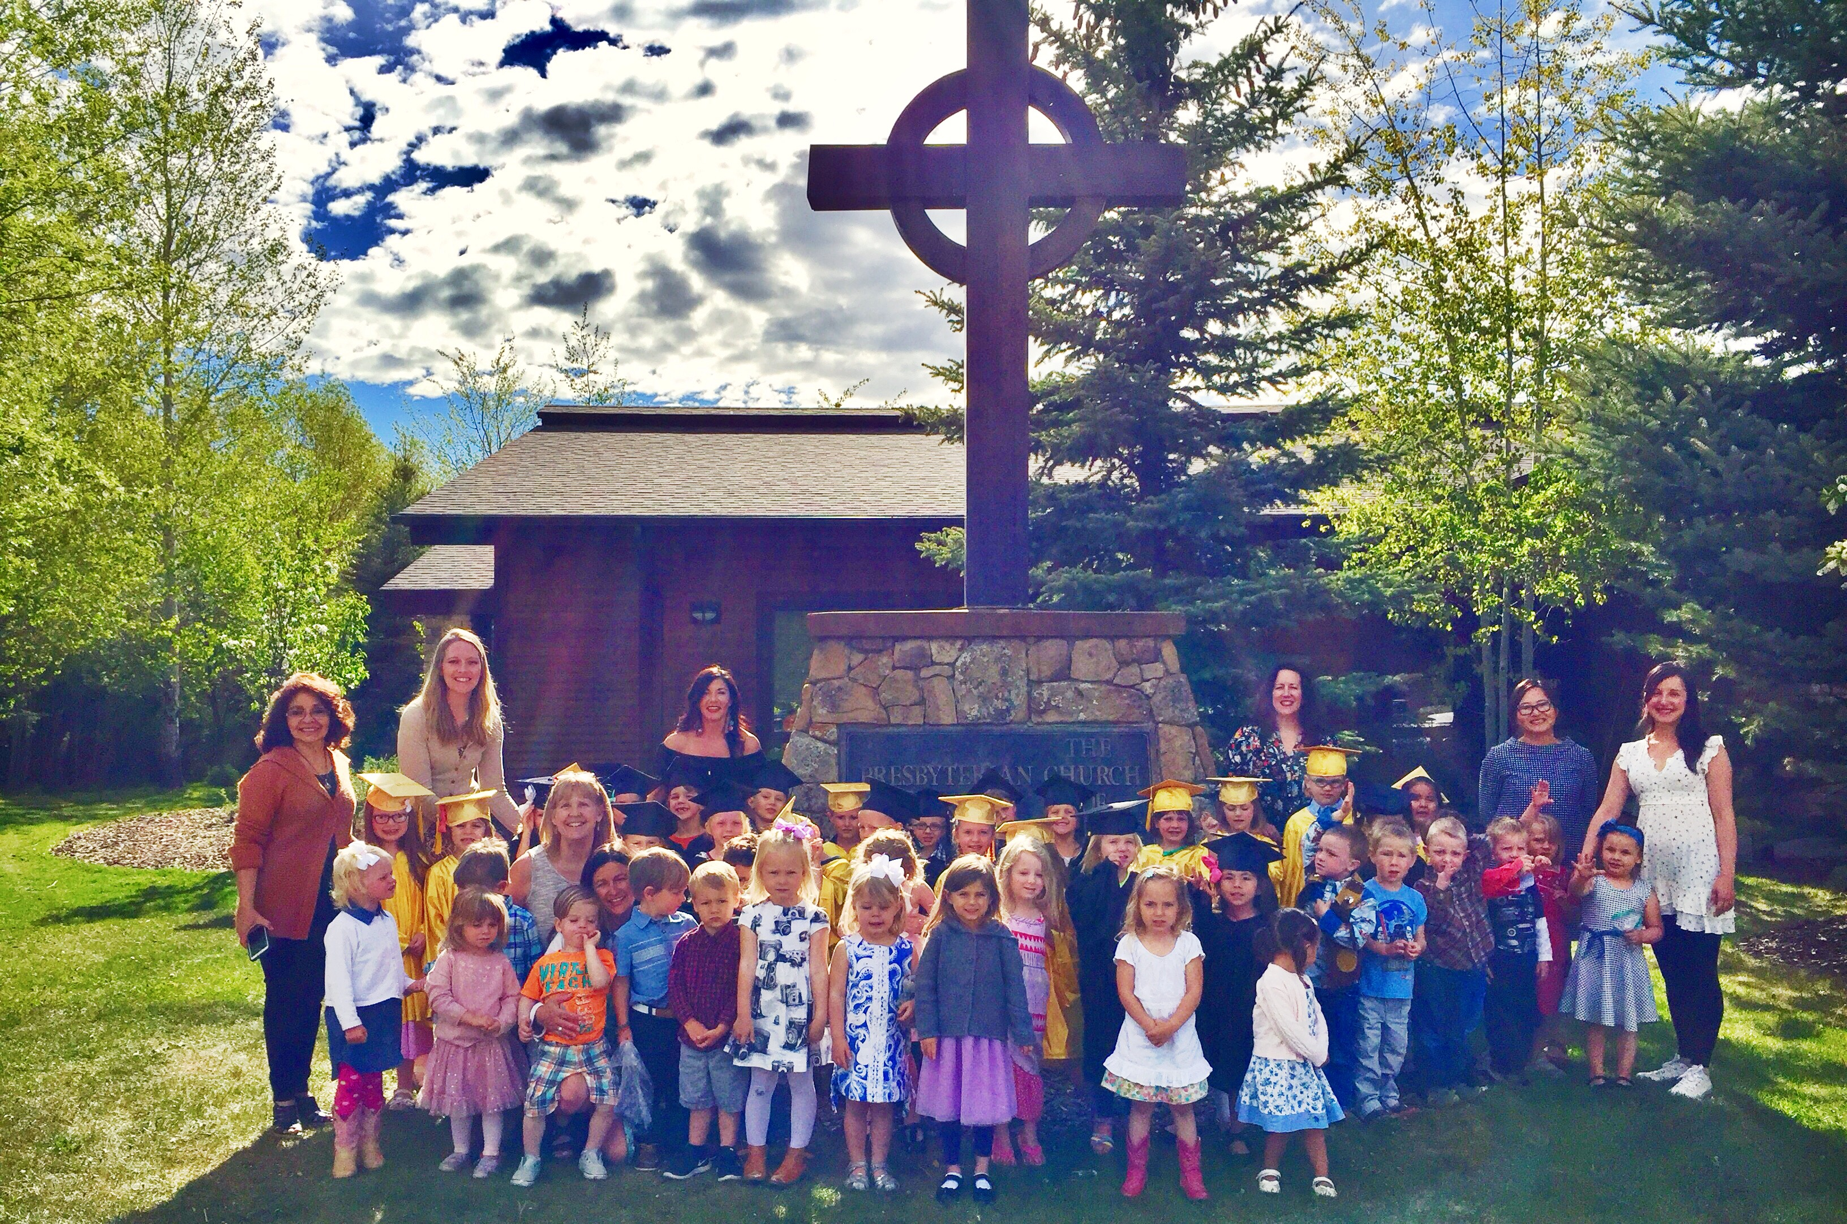

**Pizza Picnic**

Mark & Melissa Tuttle will be firing up pizzas today after the 10:15am service, join with your family & friends for this lunch!

**A Journey with Psalms**

*Sundays at 9am*

Join Pastor Tammy at 9am in the Genesis Room for this 7-week series on one of the most-loved books of the Bible.

**Final Community Dinner**

*Wednesday at 6:15pm*

Join us this Wednesday for our final community dinner before summer begins – until dinners start back up again in the fall.

**Music Academy Spring Recital**

*Wednesday, June 7th 4-5pm*

Come see the culminating performances of a semester of musical study. All are welcome; the recital will take place in the PCJH Chapel.

**PCJH Annual Rummage Sale**

*Saturday, June 10th 8am - noon*

Save the date for this year’s sale. Donate & Shop! Volunteer sign up sheets are in the Lobby, and on the PCJH website.

**Global Leadership Summit**

*August 10th – 11th*

PCJH is pleased to be a host site again this year for GLS! Head to PCJH.org & enter priority code: PHS17TEAM for our special $89 rate! Contact Sue at sueunruh@gmail.com w/ questions!

**Relay for Life**

Teton Co. Relay for Life invites local organizations to join in the fight against cancer. We're looking for a team organizer for a PCJH team for the event on June 23rd at Snow King. Contact Brian Bultema at 307-699-7081, bbultema55@gmail.com!

*Special Note: PCJH’s Joint Service with Centro de Vida Cristiana Church will take place in September, no longer in June.

**UPCOMING EVENTS & ACTIVITIES**





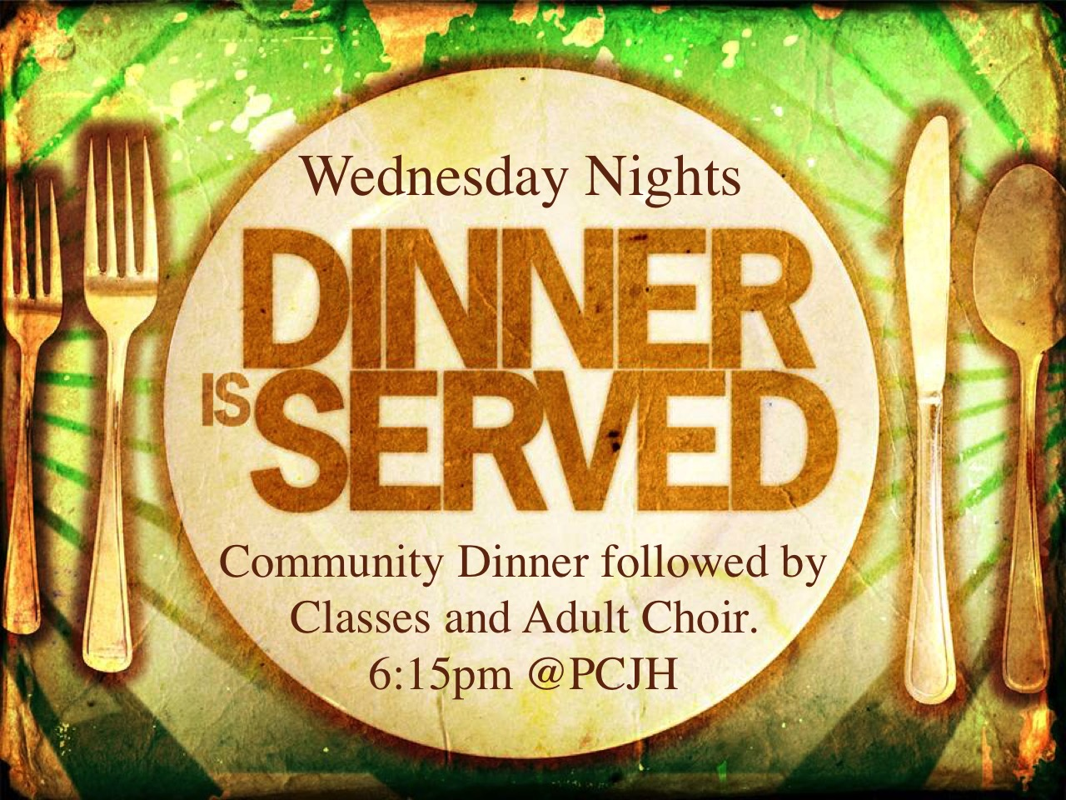









**WORSHIP**

**Sunday Worship Services:**

8:00am – Traditional Worship in the Chapel

10:15am – Contemporary Worship in the Sanctuary

**FELLOWSHIP**

**Wednesday Community Dinners** – As a church we are intentional about gathering as a community during the week. Our Wednesday dinners are 6:15-7:00pm, September through May. Before and after dinner we offer great programs and classes (see below). Contact Chef Christine Goodman if you would like to be involved in this ministry, 307-690-1199.

**Holy Yoga** – Join us for this Christ-centered, experiential worship, Mondays at 9:30am in the Genesis Room. $10 suggested donation. Come when you are able!

**MISSION & OUTREACH**

**Good Samaritan Mission** – PCJH prepares a meal at the local mission monthly, the second Thursday of every month, 5:00-6:15pm. Anyone is welcome to provide a dish for this meal and groups are encouraged! Contact Katie-Chloe Stock, katiechloe1@gmail.com.

**Stephen Ministry** – PCJH provides trained Stephen Ministers who are available to meet with you one-on-one to provide regular support and care for you during a difficult time or season in life. Please contact Pastor Ben if you would like to meet with a Stephen Minister.

**ADULT CLASSES**







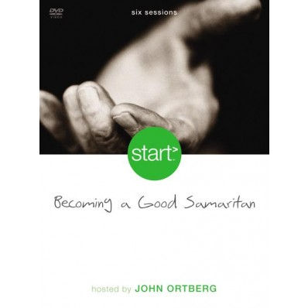



**Women’s Bible Study**

Tuesdays at 12:00pm with Pastor Ben in the Matthew Room

**Men’s Bible Study**

Thursdays at 12:00pm with Pastor Ben at Jackson Whole Grocer, upstairs in the Community Room

**Ascent (20’s & 30’s)**

Wednesdays at 7:00pm with Pastor Ben in the Matthew Room. Join us for fellowship and study.

**Becoming a Good Samaritan**

Wednesdays at 7pm with Pastor Tammy. Come learn how to live out Christ’s love in world-changing ways.

**A Journey with Psalms**

Sundays at 9am with Pastor Tammy.

Experince the nurturing power of these ancient words as they become relevant to faith & life today.

**Little Lambs Preschool**

Little Lambs provides a loving environment that promotes the social, physical, intellectual and spiritual development for your child. Little lambs runs from September – June. Classes are available 9:00am - 3:00pm, M-F, plus before and after care. Please sign up online, [www.pcjh.org](http://www.pcjh.org).

Contact Effie Edwards, [eedwards@pcjh.org](mailto:eedwards@pcjh.org)

**JOY After School**

Our After-School program is offered for any children in K-5th. The program includes pick-up at school and runs from school dismissal until 6:15pm on Weds. Please contact Dylan Wade, dwade@pcjh.org.

**Middle School**

*\*No mtg today, resumes May 21st Sundays at 4:30pm*

Come join us at PCJH for fellowship, fun, games and snacks! Contact Pastor Tammy, [tletts@pcjh.org](mailto:tletts@pcjh.org).

**Music Ministry**

Adult & Children’s choirs, and music lessons (piano, guitar, strings & voice). Contact Kenny Hadden, music@pcjh.org. Listen to our worship music on the ‘pcjhmusic’ playlist on Spotify.

**WyldLife Club**

**WyldLife Club’s next event is Friday June 9th at 8pm. Bring your camp chairs & blankets for an outdoor movie party; movie, snacks, drinks, fire pit & s’mores! Location: DYNIA Architecture Studio Loft, 1085 W Hwy 22 – up & right!**

**GET TO KNOW US**

**Pastoral Staff**

Rev. Ben Pascal bpascal@pcjh.org

*Senior Pastor x 101*

Rev. Tammy Letts tletts@pcjh.org

*Associate Pastor x 104*

**Office Staff**

Cindy Dahlin cdahlin@pcjh.org

*Church Administrator x109*

Liz Collins lcollins@pcjh.org

*Interim Communications Coordinator*

Pam Flores pflores@pcjh.org

*Office Assistant x107*

**Program Staff**

Kenny Hadden music@pcjh.org

*Worship Coordinator x123*

Effie Edwards eedwards@pcjh.org

*Little Lambs Director x111*

Dylan Wade dwade@pcjh.org

*Children’s Ministry Coordinator x103*

Liz Collins lcollins@pcjh.org

*Interim Youth Ministry Coordinator*

**Ruling Elders**

Ruling Elders are the spiritual leaders of the church.

Session meetings are the third Tuesday of every month at 5:30pm.

Class of 2017 2018 2019

### Katie-Chloe Stock Barb Andrews Alan Lund*

### *Missions Youth Ministry Finance*

### Patty McDonald* Pat Wright Barbara Carlsberg

*Personnel Stewardship Worship*

Ken Blount Peter Keenan Aaron Nydam

*Clerk of Session Buildings & Children’s Grounds Ministry*

### Kerry MurphyWarren Meg Womack

### *Nominating and* VanGenderen *Congregational*

### *Member Assimilation Adult Ministries Life*

**Deacons**

Deacons provide the ministry of compassion

and service for those in need.

Class of 2017 2018 2019

Nancy Brumsted Jen Baki Liz Jorgenson

Jackie Montgomery Dylan Wade Annie Mueller

Carol Poole Paula Jorgenson Marge McCallister

Sandra Zender Erin Rosenberg Tom Deltz

Karen Brennan* Deb Keenan Dorothy Neckels

Joanie Shipman* Yvonne Henze* Alicia Neathery

Julie Whitlock* Tena Webb* Susan Hawkins

Randy & Robyn Barb Huhn* Kenlyn Long*

Reedy*

*serving second term

**CHILDREN & YOUTH MINISTRY**

**Nursery**

0-3 years old

Sundays, 8:00-11:30am

Wednesdays, 5:15-8:00pm

**Sunday School**

We gather weekly during the 10:15 worship service and have classes based on age groups: 4yrs-K, 1st-2nd grade, 3rd-5th grade and 6th-8th grade. We strive to develop a loving personal relationship with each child and help them grow in their relationship with Jesus Christ. On First Sundays, we offer a large group activity in the Chapel for all ages.





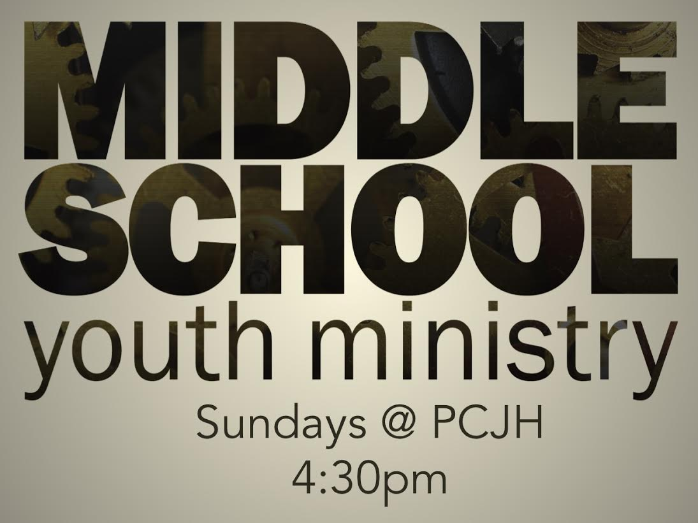

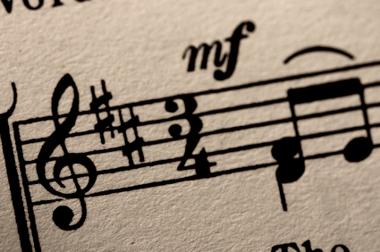



**WE GROW BY LISTENING FOR GOD’S WORD**

**A Message from God’s Word**

Acts 17:16-34 Page 785

**Song of Preparation**

*Holy Spirit*

**Time for Reflection and Study** Rev. Ben Pascal

*Engaging the Culture*

**CELEBRATING THE SACRAMENT OF THE LORD’S SUPPER**

**Preparing Our Hearts for the Lord’s Supper**

*Kyrie Eleison*

*(Children now re-enter the Sanctuary).*

All who have received Jesus Christ as their Savior and Lord are welcome to share in the Lord’s Supper. Those who are not ready to take communion may receive a blessing from one of the pastors.

**The Great Thanksgiving**

One: The Lord be with you.

**All: And also with you.**

One: Lift up your hearts.

**All: We lift them to God.**

One: Let us give thanks to God.

**All: It is right to give our thanks and praise.**

**Invitation to the Table**

**The Apostles’ Creed**

**The Lord’s Prayer**

**Preparing the Table**

*(Elders & Deacons serving Communion, please come forward)*

**Sharing in the Lord’s Supper**

*(As you receive the elements this morning, move to the server nearest you. Take a piece of bread, dip it in the cup, eat, and then return to your seat. The pastors are available to pray with you as you head back to your seat.)*

**WE GO TO MAKE A DIFFERENCE IN GOD’S WORLD**

**The Benediction**

*Let There Be Love Shared Among Us*

**Fellowship in the Lobby**

(Please enjoy food and fellowship after the service,

and stop by the welcome table on your way out.)

**HOW TO STAY CONNECTED**

** Website:** www.pcjh.org  **Facebook** **Online Directory**  **Annual Report**

Create an account to access, Available for pick-up &

how to on our website. viewable on our website.

 **Weekly Email**  **Newsletter**

Let us know if you would Available for pick-up in

like your email added, the Lobby, view online,

office@pcjh.org or by mail upon request

 **Sermons Online**  **Prayer Requests**

pcjh.org/online-sermons/ pcjh.org/prayer-requests/

**HOW TO STAY CONNECTED**

** Website:** www.pcjh.org  **Facebook**

 **Weekly Email**  **Newsletter**

Let us know if you would Available for pick-up in

like your email added, the Lobby, view online,

office@pcjh.org or by mail upon request

 **Sermons Online**  **Prayer Requests**

pcjh.org/online-sermons/ pcjh.org/prayer-requests/

“Be joyful always, pray continually, give thanks in all circumstances, for this is God’s will for you in Christ Jesus.”

*- 1Thessalonians 5:16-18*

**WE GATHER IN GRATEFUL WORSHIP**

**Song of Gathering**

*My Sweet Lord*

**Welcome and Call to Worship**

One: Spirit of the Living God, visit us again on this day of Pentecost

**All: Come, Holy Spirit**

One: With rushing wind that sweeps away all barriers

**All: Come, Holy Spirit**

One: With tongues of fire that set our hearts aflame

**All: Come, Holy Spirit**

One: With speech that unites the Babel of our tongues

**All: Come, Holy Spirit**

One: With love that overlaps the boundaries of race and nation

**All: Come, Holy Spirit**

One: With power from above to make our weakness strong

**All: Come, Holy Spirit**

**Songs of Praise**

*I Shall Not Be Moved*

*10,000 Reasons*

**Prayer of Confession for Pentecost**

Our God, we come in humility, confessing who and what we are. We are often unresponsive for we are afraid. When your Spirit speaks, we turn deaf ears, for we fear what you might call us to do. When your Spirit touches our lips, we close our mouths, embarrassed to speak your Word. When the wind of your Spirit blows, we close the windows of our hearts, afraid the breeze will disrupt our ordered lives. When the fire of your Spirit touches us, we quench the flame, afraid of the new life it might bring. Forgive us, O Lord.

**Words of Assurance**

**Song of Response**

*Thank You, Lord*

**Passing the Peace of Christ**

(Take a few moments to greet one another)

**A TIME FOR FAMILY CELEBRATION**

**High School Recognition**

*Nils Huot - WY Tech*

*Christian Iobst - University of Wyoming*

*Sarah Andrews - Montana State University*

*Shaeli Funk - Pepperdine University*

*Bridget Murphy - Colorado State University*

*Cecelia Williams - Vanderbuilt University*

*Savannah Huhn - Denver Institute of Massage Therapy*

*Ian Lewis - Montana State University*

*Tiffanni Walker – University of Wyoming*

(Children are now dismissed to Sunday School)

**News of the Church Family**

(Please sign and pass the welcome pads)

**Giving Generously of our Tithes and Offerings**

(Electronic giving instructions are on the back bottom of this bulletin)