The Presbyterian Church of Jackson Hole

Worship & Music Director

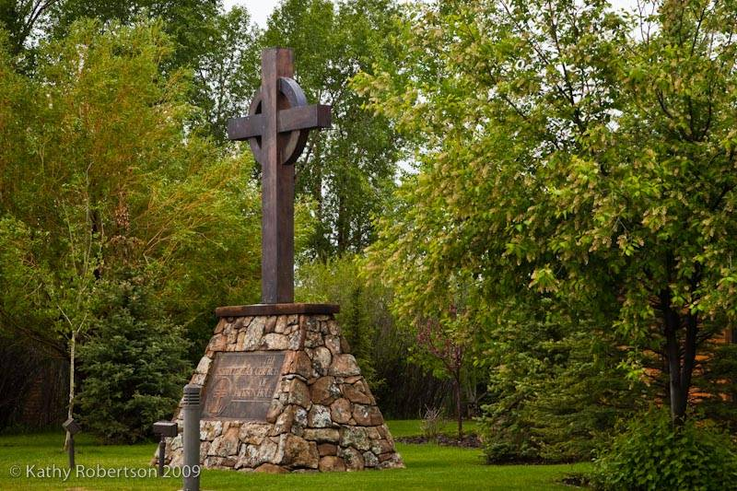

Worship & Music Director

The Worship & Music Director serves the Jackson Hole community and seeks to fulfill the purpose of the Presbyterian Church of Jackson Hole as outlined in the Vision and Mission Statement.

Our vision is to see lives being transformed in Jesus Christ.

Our mission is to be a community, rooted in Christ, reaching out in love.

As we live out this mission, PCJH is committed to being a Christ-centered, Biblically-based, healthy congregation that welcomes all, does its ministry and mission with excellence, and is present in our community and world as salt and light. Our beliefs are reflective of the Reformed tradition from which our denomination, the Presbyterian Church (USA) has grown.

Please visit us at:
www.pcjh.org
www.facebook.com

About our Church and Community
The Presbyterian Church of Jackson Hole is a community-based, Christian church. At PCJH you will find people from many denominational backgrounds... and none; some younger and those a bit older; the politically conservative and others who are liberal; richer folks and poorer folks; those from “born-again” experiences and others from an “actions speak louder than words” belief; some with a deep knowledge of the Bible and some with just a preliminary understanding of the Scriptures. What holds us together is a heart of gratitude to God for the reality of God’s grace in our lives; a desire to become more like Jesus, God’s son and our Lord; and an active caring for our neighbor.

As a church, we gather weekly on Sundays and Wednesdays. There are also many other programs, special events and small groups that meet throughout the rest of the week. Our Sunday morning worship attendance averages 250 people between our 8:00am and 10:15am worship services. The Sunday morning adult education hour averages 15 people. On Wednesday night we provide adult classes, a community dinner, choir practice, and a young adult gathering. Our community dinner draws an average of 125 people each week for food, conversation and fellowship.

Being a church in one of the most popular resort towns in the world requires a unique model of ministry. We have many people who come and go as seasonal residents, as well as people who come and go due to the fact that Jackson Hole is often a place of transition as people move onto whatever is next in their lives. Many people who live in Jackson Hole are people who love the outdoors (skiing, river rafting, fly fishing, hunting, hiking, climbing, paragliding, mountain biking, etc.). Many come here as young adults wanting to play; families who want to raise their children with an outdoor lifestyle; or people who are fortunate enough to retire here. We have another large segment of our population who are immigrants from Latin America and Eastern Europe who work in many of the service industries. Jackson is a small town with many urban amenities, restaurants, non-profit organizations and services. It is a strong community of people who are committed to one another.

The beauty of Jackson Hole is beyond comparison. Jackson is the gateway to Grand Teton and Yellowstone National Parks. It is a place that captures the hearts of many from all over the world. It is truly a blessing to have the opportunity to live, work and play in Jackson Hole. It is an even greater blessing to be able to proclaim the gospel and do ministry in a town like Jackson, Wyoming… the last of the Old West.

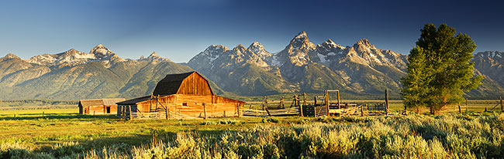
Worship & Music Director
Job Description

A. Title: Worship & Music Director

B. Summary and Purpose of the Position

The position of Worship & Music Director exists in order to inspire and draw people into the presence of God. Our hope is to see lives being transformed in Jesus Christ as we live out our mission to be a community, rooted in Christ, reaching out in love. The Worship & Music Director is responsible for the day-to-day functions of specific programs and ministries that pertain to worship and music at PCJH.

The Worship & Music Director is a frontline person with whom the congregation will interact, and must be able to create an environment that is welcoming, energetic, and inspiring, with theological depth. This requires a person with a strong presence and faith who is skilled in music. Leadership also requires the ability to graciously handle unexpected or difficult situations and to value the diversity of skills and unique gifts of each individual as we encourage every member to be a minister. A spirit of teamwork, a positive attitude, and a genuine heart for servant-leadership are essential.

The Worship & Music Director will manage the hands-on development, implementation and management of established worship and music programs as well as administrative details required, and communication within the organization and congregation.

The Worship & Music Director is a full-time position and will report to the Senior Pastor and will collaborate with staff and key volunteers.

C. Qualifications

- A love of God through Jesus Christ, demonstrating growth and maturity in faith.
- A passion for the gospel.
- A strong sense of call, passion and commitment to leading worship.
- Strong relational skills, realizing that faith is primarily formed through personal, trusted relationships.
- A commitment to PCJH; its worship, fellowship, theology and philosophy of ministry.
- A commitment to personal, spiritual, and professional development.
- A minimum of a bachelor’s degree with training in music theory.
- Ability to skillfully play a musical instrument such as guitar or piano, and familiarity with other commonly used instruments used in worship.
- Knowledgeable in Christian worship history and current music and liturgical trends.
- Experience working with musicians and leading bands and choirs.
- Able to lead, motivate, and empower teams of musicians.
- Presents a positive impression through written, verbal, and relational skills.
- Demonstrates flexibility, organization and planning skills.
- Knowledgeable in clerical, communication, and computer skills to include literacy in Mac OS X, Microsoft Office including PowerPoint, music and video editing software.
- Knowledgeable in setting up and using musical equipment, microphones, monitors, lighting, projectors, audio/visual equipment, and a digital sound board.

D. Responsibilities

Worship Teamwork
  - Invite, equip, and empower volunteers for worship ministry.
  - Regularly meet with the PCJH worship committee.
  - Regular meetings with the Senior Pastor and PCJH staff.
  - Build relationships with musicians by being active in the local music community.
  - Challenge and encourage volunteers/musicians in their Christian faith.

Worship Planning and Preparation
  - Prepare for Sunday worship by working with staff to select songs and finalize bulletin details; set up musical equipment and chairs, ensure sanctuary is clean, organized and presentable; provide detailed music for musicians; prepare PowerPoint slides, video clips, and possible artwork or liturgical accessories.
  - Work with the Senior Pastor in planning out song selection months in advance in order to provide choir and/or the band with a schedule, music, and a CD to listen.
  - Coordinate rehearsals with the band and/or choir during the week and on Sunday mornings at 9:00am. Wednesday rehearsals with praise band at 5:15pm and choir at 7:00pm.
  - Coordinate and train volunteers to run the sound board and PowerPoint.
  - Oversee the worship budget.
  - Maintain church copyright status in order to legally play songs/movies in worship.

Worship Leadership
  - Lead Sunday morning worship at 8:00am and 10:15am, in partnership with the pastors, in order to inspire and draw people into the presence of God through music, Scripture, words of reflection, and prayer.
  - Provide leadership for the worship band, choir, and/or special music.
  - Conceptualize, film, and edit videos to aid in worship as sermon illustrations or announcements.
  - Recruit and develop Adult and Children’s Choirs that are known for musical excellence and inspirational worship.
  - Coordinate special performances for Christmas and Easter, as appropriate.
  - Provide music instruction and worship leadership for CYF ministries, including Little Lambs, JOY Summer Camp, and JOY After School.
  - Develop and administrate the PCJH Music Academy to connect people to God through music and build worship resources at all age levels in the church.
  - Offer adult education on various aspects of worship, as appropriate.
  - Be available to help lead worship for special events, retreats, or other gatherings throughout the week. Occasionally lead worship for CYF and Adult Ministries.
  - Provide music and/or audio/visual leadership for special events (i.e. Upward Basketball Award Ceremony, Little Lambs Presentations, Christmas Story, retreats, funerals, rentals, etc.)

Worship Follow-Up
- Seek feedback and evaluation on how to improve and enhance worship.
- Record and post sermons to the PCJH website within 48 hours.
- Maintain music and audio/visual equipment in the entire church.

Other
- Other duties as assigned

E. Supervision

Under the direct Supervision of the Senior Pastor

F. Accountability

The Worship & Music Director agrees to abide by the personnel and Safe Church policies as adopted by the Church Session.

As with all staff, the Worship & Music Director is accountable to Jesus Christ, Head of the Church, and to the Session of PCJH.

G. Compensation and Benefits

PCJH will provide a competitive wage and benefits package commensurate with experience. All PCJH employees receive a 50% discount on PCJH childcare programs.

WORSHIP & MUSIC DIRECTOR APPLICATION
(Please include a cover letter)

Please be sure your application is COMPLETE before turning it in.

Please deliver applications to the Presbyterian Church of Jackson Hole:

c/o Rev. Tammy Mitchell
Worship & Music Director Search Committee
The Presbyterian Church of Jackson Hole
1251 South Park Loop Road (for Fed Ex or UPS)
P.O. Box 7530 (for USPS)
Jackson, WY 83001

Phone: 307-734-0388
Fax: 307-734-0220
Email: tmitchell@pcjh.org

General Information

Applicant’s Name: _____________________________ Date of Birth: _______________

Physical Address _________________________________________
City, State, Zip _________________________________________

Mailing Address _________________________________________
City, State, Zip _________________________________________

Phone: _________________________________________
Email Address: _________________________________________

Name of church with which you are affiliated: ____________________________
Presbytery(if applicable):_________________ Phone:____________
Pastor’s Name: ___________________________________________
Church Address: ______________________________
City, State, Zip: _______________________________

The desired start date for the Worship & Music Director is September 1st, 2019. We are open to God’s timing and therefore the start date is open to discussion. What is your available start date? ____________ What is your preferred start date? _____________

Required Background Information

Have you ever been convicted of a felony or misdemeanor? If yes, please explain. ______________________________________________________________________ ______________________________________________________________________

Have you ever been convicted of driving under the influence? If yes, please explain. ______________________________________________________________________
______________________________________________________________________

Are you a registered sex offender? ________________________________________

We require staff and volunteers to complete a national background check. Is there any reason this would be a problem for you? If yes, please explain. ______________________________________________________________________
______________________________________________________________________

Please include the following materials in your application packet:
- Cover Letter
- Application Form (pages 7 and 8)
- Answers to our Nine Questions (see page 9)
- Waiver/Release (see page 10)

Next Steps in the Search Process
Upon receipt of your completed application packet, we will notify you to confirm our having received it. If, after reviewing your application, we feel that you are a potential candidate for the position of Worship & Music Director at PCJH, we will schedule a phone and/or Skype interview. The committee will then invite the final candidate(s) to Jackson Hole for an in-person interview. If at any time the committee feels that you are no longer a viable candidate, we will inform you in a timely manner. Please keep this search process in your prayers. We will certainly lift you up in prayer as well. Blessings to you as the Lord guides and directs us all.

May God’s blessings be upon you,
~PCJH Worship & Music Director Search Committee

We would like to get to know you better. Please respond briefly (one page maximum per question) to the following questions:

1. Please describe your faith journey. Include how God got your attention and some significant experiences throughout your journey. How has this journey prepared you for this position?

2. What voices have been important to you in your faith journey, and how have they
been valuable? Please include any mentors, pastors, authors, or Scripture.

3. Suppose that someone you feel comfortable with and know very well had asked you to explain the Christian faith to him or her. What would you do and what would you say?

4. Please describe a situation where you encountered conflict. What did you do about it, what was the outcome, and what did you learn from it?

5. Please describe your experience with worship leadership. What types of liturgy, music, and art are you most interested in as you craft a worship service? What instruments do you play? What is your experience with audio/visual and lighting equipment as it relates to worship?

6. Describe a worship service that you enjoyed being involved with and contributing to. What about it was most enjoyable and what were the less enjoyable aspects for you?

7. Please describe your experience with teaching music lessons and/or directing a music academy. What is your approach to music education?

8. After reviewing the job description for the Worship & Music Director, what aspects of the job are you most passionate about and why? Also, which areas are you least excited about and why?

9. How does this position fit into your short and long-term goals?

Please also include a current photograph of yourself when you submit your answers to the above questions. Thank you!

~PCJH Worship & Music Director Search Committee
Staff Application ~ Release/Waiver

I, the undersigned, give my authorization to the Presbyterian Church of Jackson Hole’s representatives – hereafter referred to as The Church – to verify the information on my application and personal information forms. The Church may contact my references, employers and appropriate government agencies as deemed necessary in order to verify my suitability as a pastor. I am willing to request and submit to The Church background reports on myself from the National Registry.

The information contained in this application and my personal information form is correct to the best of my knowledge. I authorize any references or churches listed in my application and personal information form to give you any information (including opinions) that they may have regarding my character and suitability for ministry. In consideration of the receipt and evaluation of this application by The Church, I hereby release any individual, church, youth organization, charity, employer, reference, or any other person or organization, including record custodians, both collectively and individually, from any and all liability for damages of whatever kind or nature that may at any time result to me, my heirs, or family, because of compliance or any attempts to comply, with this authorization. I waive any right that I may have to inspect any reference information provided about me by any person or organization identified by me in this application. I may, however, request to see the National Registry printout of my background search.

Should my application be accepted, I agree to be bound by the constitution, statement of faith and policies of The Church, and to refrain from conduct unbecoming to Christ in the performance of my services on behalf of The Church. If I violate these guidelines, I understand that my employment status may be terminated, as determined at the sole discretion of The Church. By signing this application, I state that all of the information given about myself is true.

I further state that I HAVE CAREFULLY READ THE FOREGOING RELEASE/WAIVER AND KNOW THE CONTENTS THEREOF, AND I SIGN THE RELEASE/WAIVER AS MY OWN ACT. This is a legally binding agreement which I have read and understand.

___________________________ ___________________________ __________
Printed Name of Applicant Signature Date

___________________________ ___________________________ __________
Printed Name of Witness Signature Date

